Project Design Phase-II
Technology Stack (Architecture & Stack)
Date | 28 September 2026
Team ID | SWTID-2026-1668
Project Name | Streamlining IT Procurement: Automating Standard Laptop Orders With Flow Designer
Maximum Marks | 4 Marks

Technical Architecture:
Architecture of the automated standard laptop ordering process built with Flow Designer on the ServiceNow cloud platform, with the component and characteristic details in Table-1 and Table-2.
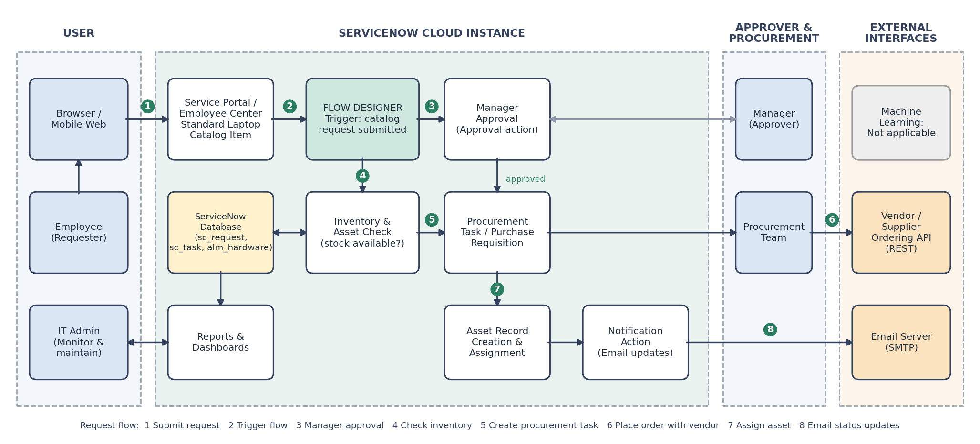
Table-1 : Components & Technologies:
S.No | Component | Description | Technology
1. | User Interface | Employees raise a standard laptop request through the Service Catalog on a web/mobile browser; managers approve from the portal or email. | ServiceNow Service Portal / Employee Center (HTML, CSS, JavaScript, AngularJS widgets)
2. | Application Logic-1 | Request submission: standard laptop catalog item with variables, auto-populated requester details and field validation. | Service Catalog Item, Variable Sets, Catalog Client Scripts (JavaScript)
3. | Application Logic-2 | Approval and fulfilment automation: flow triggered on request, manager approval, inventory check and procurement task creation. | ServiceNow Flow Designer (flows, subflows, actions), Approval Rules
4. | Application Logic-3 | Asset creation/assignment and status notifications to the requester at each stage. | Flow Designer actions, Notifications, server-side JavaScript (GlideRecord)
5. | Database | Request, request item, task, approval and asset data (sc_request, sc_req_item, sc_task, alm_hardware). | ServiceNow platform relational database (tables and records)
6. | Cloud Database | Database service hosted with the ServiceNow cloud instance; no separate database server to manage. | ServiceNow Cloud Instance (Personal Developer Instance for development)
7. | File Storage | Attachments such as quotations, invoices and delivery documents linked to requests. | ServiceNow Attachments (sys_attachment)
8. | External API-1 | Sends confirmation and status-update emails to requesters and approvers. | SMTP email service (ServiceNow Email Notifications)
9. | External API-2 | Places the laptop order with the approved vendor / supplier. | Vendor ordering API via REST Message / IntegrationHub
10. | Machine Learning Model | Not applicable in the current scope; the process is rule-based automation. | N/A
11. | Infrastructure (Server / Cloud) | Application deployment on the cloud. Local Server Configuration: none required, only a web browser on the user’s device. Cloud Server Configuration: ServiceNow-hosted cloud instance (SaaS/PaaS). | Cloud (ServiceNow Cloud Instance)
Table-2: Application Characteristics:
S.No | Characteristics | Description | Technology
1. | Open-Source Frameworks | Open-source front-end libraries used in the portal widgets and client-side scripting. | AngularJS, Bootstrap, JavaScript
2. | Security Implementations | Role-based access control (ACLs) for employee, manager, procurement and admin roles; SSO login; secure HTTPS communication; data encryption; audit logs of approvals and fulfilment. | SSO / SAML, ServiceNow ACLs and Roles, HTTPS/TLS, Audit logs, OWASP guidelines
3. | Scalable Architecture | 3-tier architecture (browser client, application layer, database layer); reusable flows, subflows and catalog items allow more hardware types and higher request volumes to be added without redesign. | ServiceNow multi-tier cloud platform, Flow Designer subflows
4. | Availability | Cloud-hosted instance on the ServiceNow platform with redundant infrastructure, load-balanced application nodes and backups, so the ordering process stays available. | ServiceNow Cloud (load balancing, redundancy, backup and recovery)
5. | Performance | Asynchronous flow execution, indexed tables and platform caching keep request submission and approval routing responsive; workload is handled by the cloud platform. | Flow Designer asynchronous execution, ServiceNow platform caching

